Student Performance Predictor & Tracker

In this work we have created automated online application to track student’s performance which consists of following modules

1. Admin Dashboard: admin can login to system using username and password as admin and admin
2. Add Faculty Details: after login admin can add new teacher details by using this module
3. Add Students Details: can add new students details
4. View Teacher Details: can view list of all existing teacher details
5. View Student Details: can view list of all existing students details
6. Resource Allocation: can allocate school resources to employees
7. School Performance: can view performance of all teachers based on average grades obtained by student’s under that teacher

Teacher Dashboard

1. Teacher Login: teacher can login to system using username and password given by admin:
2. Add Attendance: can add attendance of student’s
3. Create Assignment: can create new task or assignment details
4. Upload Materials: can upload and share study material with students
5. Add Marks: can add students marks subject wise
6. Messaging: can send messages to students and parents
7. View Progress Report: can view grades and marks for each students
8. View Student Messages: can view messages posted by students

Students Dashboard

1. Student Login: can login to system using username and password given by admin
2. View Upcoming Assignments: can view new upcoming assignment task details
3. Messaging: can post doubts or messages to teacher
4. Download Material: can view list of material uploaded by teacher and can download desired material
5. View Marks: can view marks for all subjects
6. View Messages: can view messages sent by teacher.

To run project install MYSQL database and then open MYSQL console and then copy content from database.txt and paste in MYSQL console to create database

Install python 3.7.2 and then install all packages given in requirements.txt file and then double click on ‘run.bat’ file to start python web server and will get below page

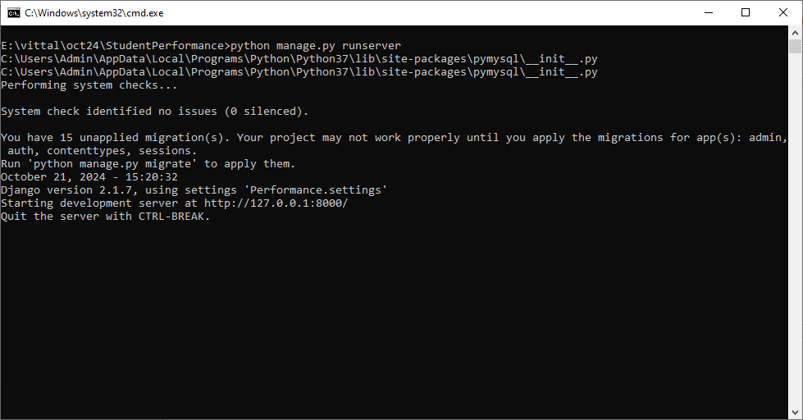

In above screen python web server started and now open browser and enter URL as <http://127.0.0.1:8000/index.html> and press enter key to get below page

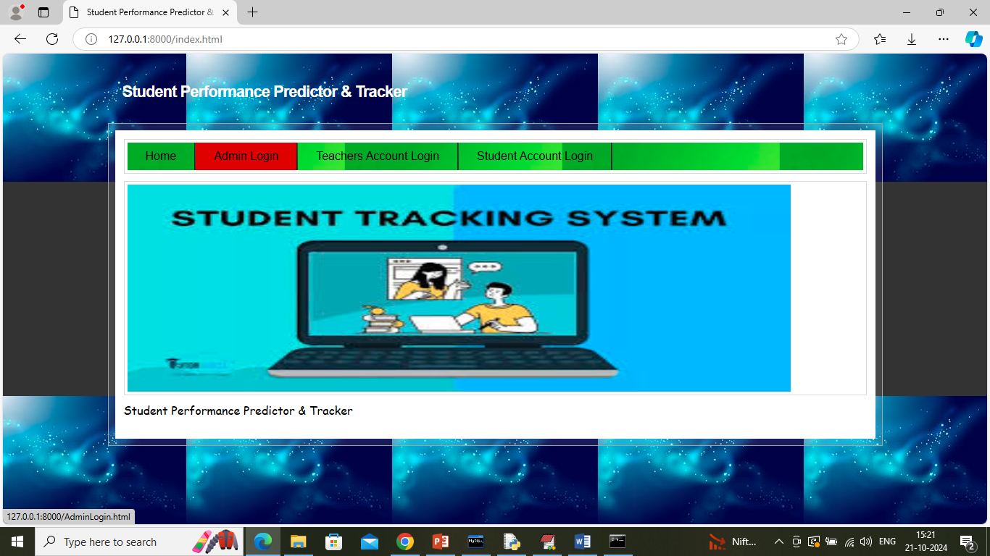

In above screen click on ‘Admin Login’ link to get below page

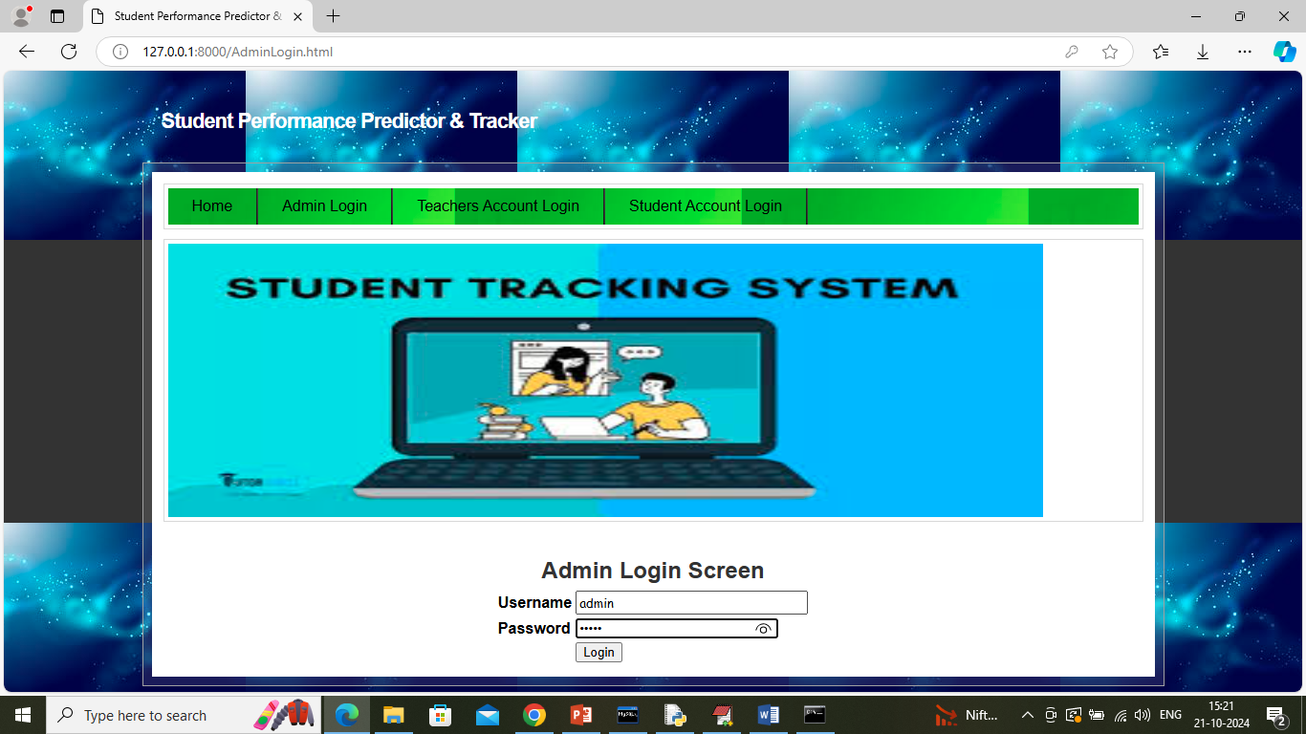

In above screen admin is login and after login will get below page

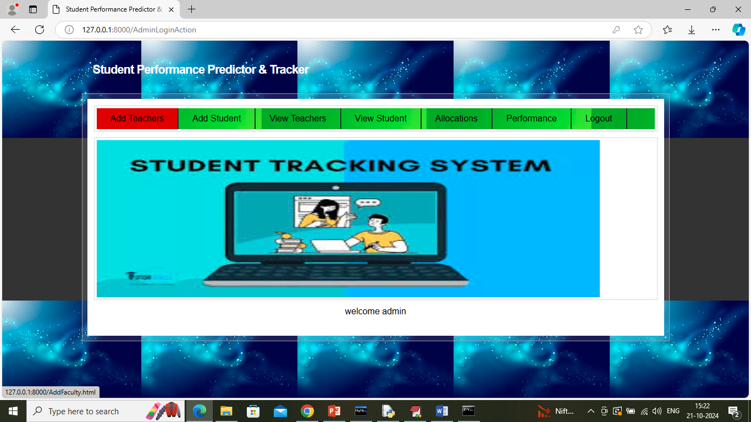

In above screen admin can click on ‘Add Teacher’ link to get below page

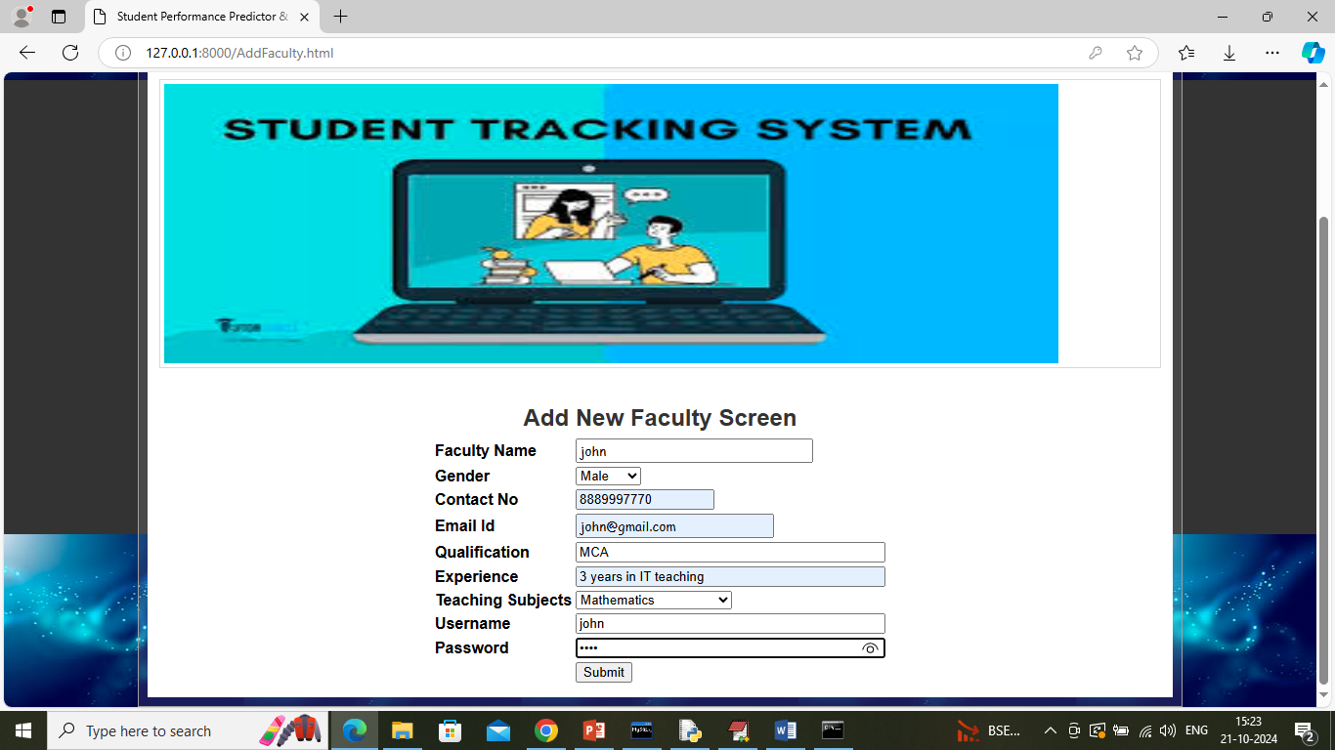

In above screen admin will add new teacher details and then press button to get below page

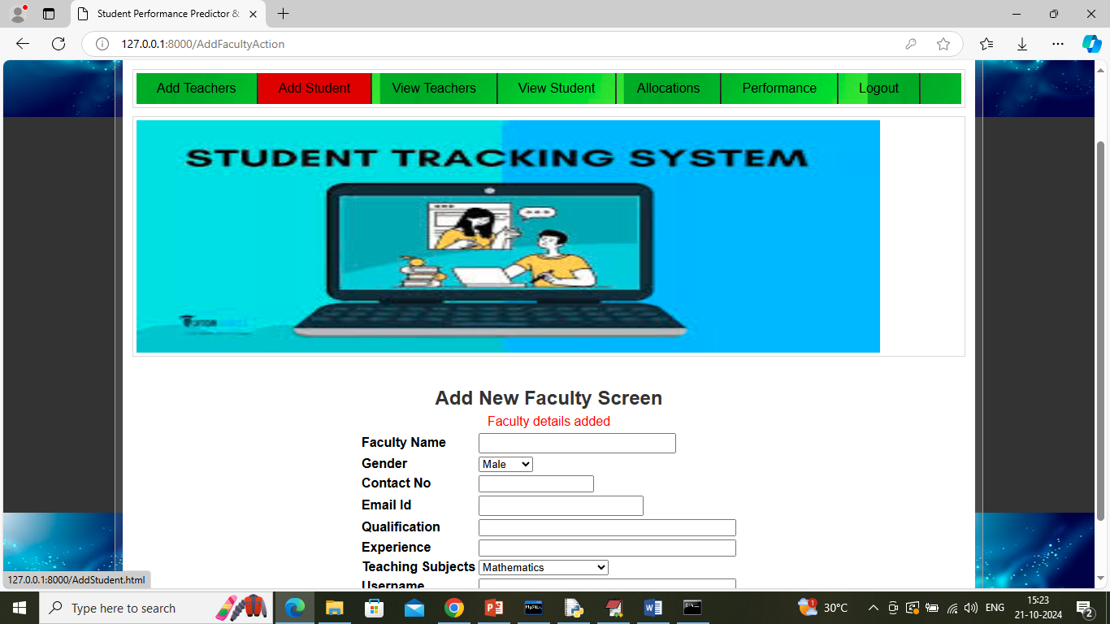

In above screen new teacher or faculty details added and now click on ‘Add Student’ link to get below page

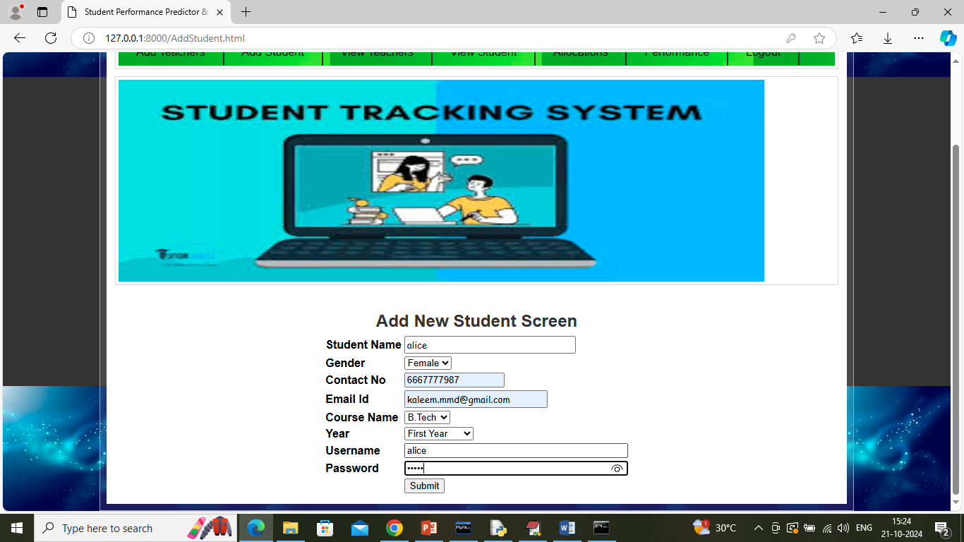

In above screen admin adding new student details and give valid mail id to get emails from teachers and then press button to get below page

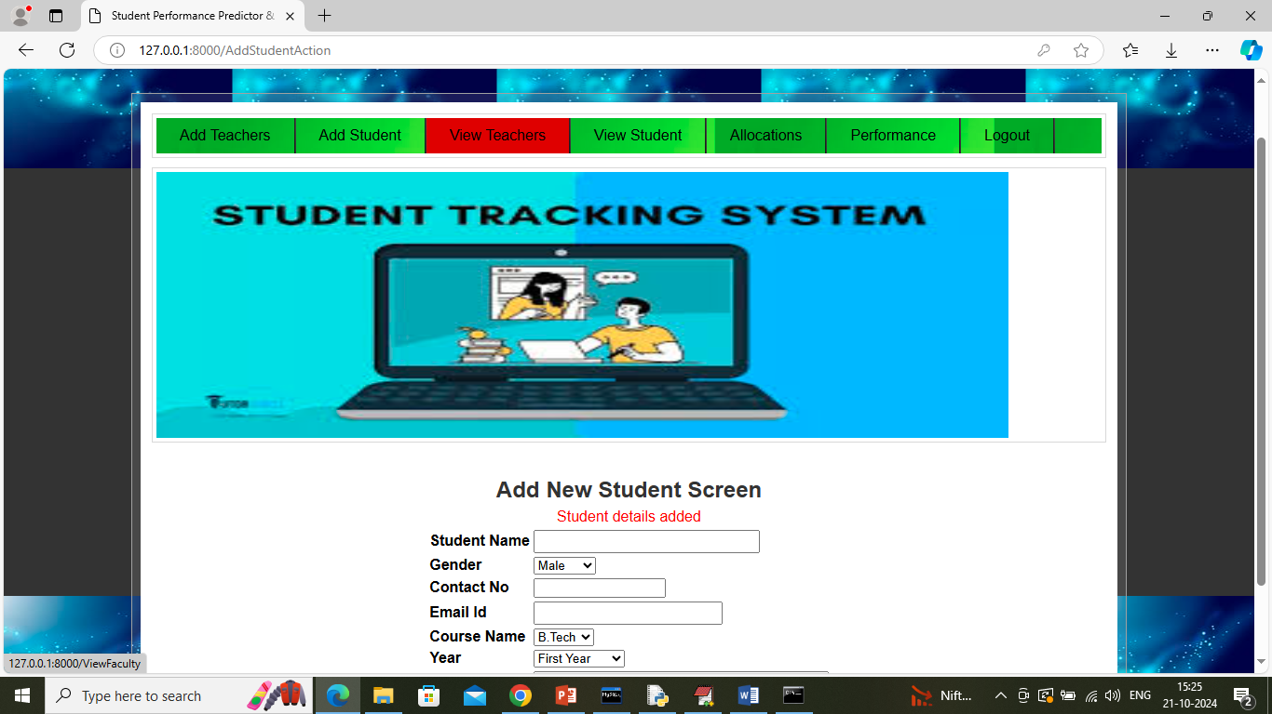

In above screen students details added and now click on ‘View Teachers’ link to get below page

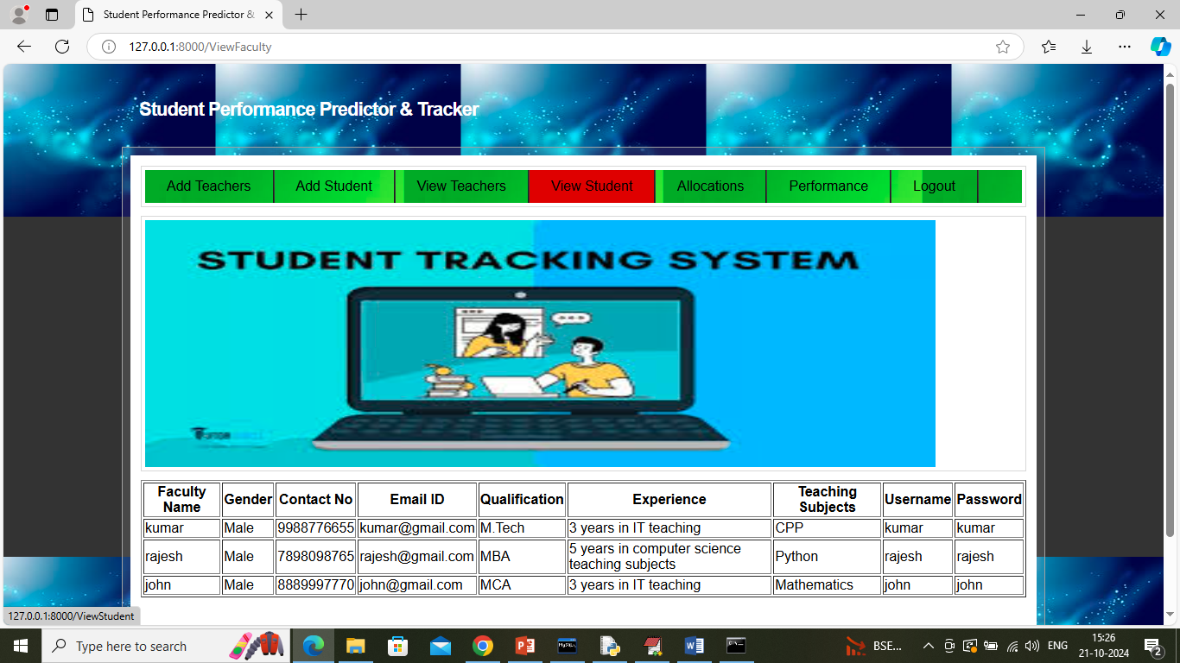

In above screen admin can view list of available teachers and now click on ‘View Students’ link to get below page

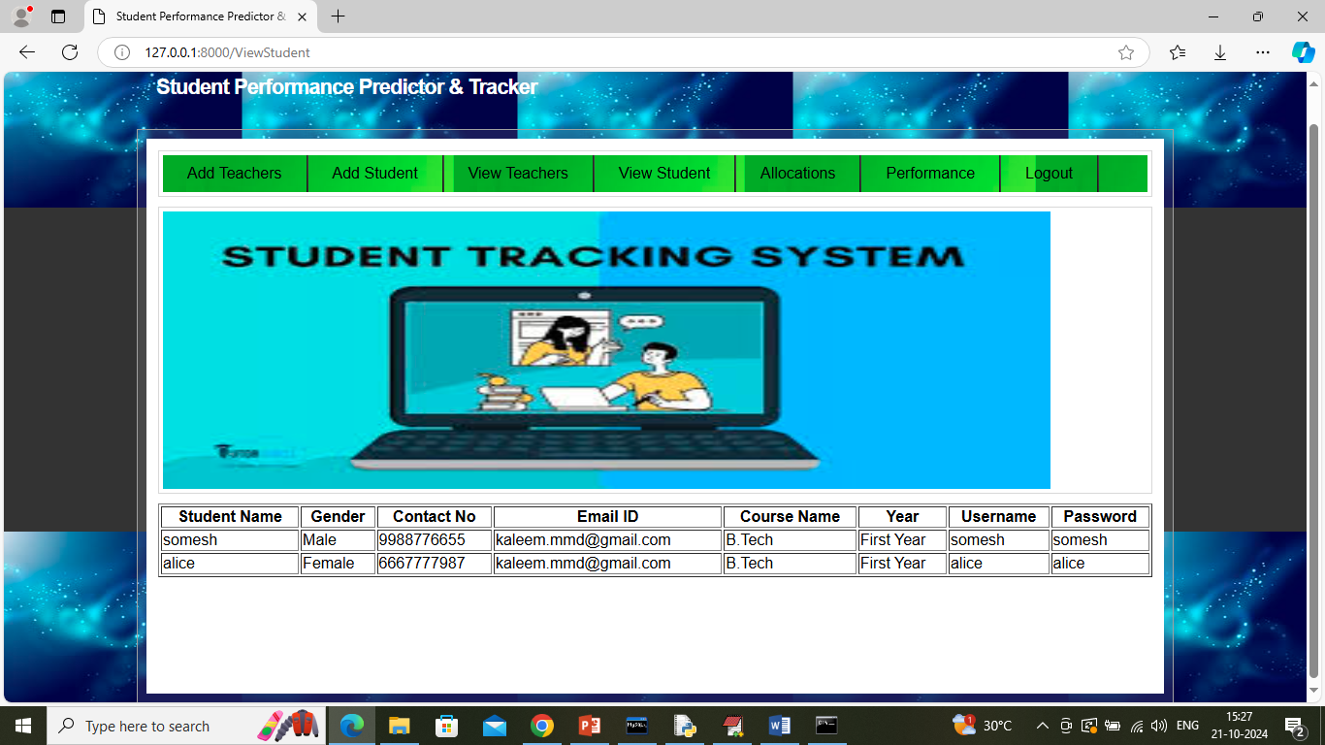

In above screen admin can view list of available students and now click on ‘Allocation’ link to allocate resources to employees

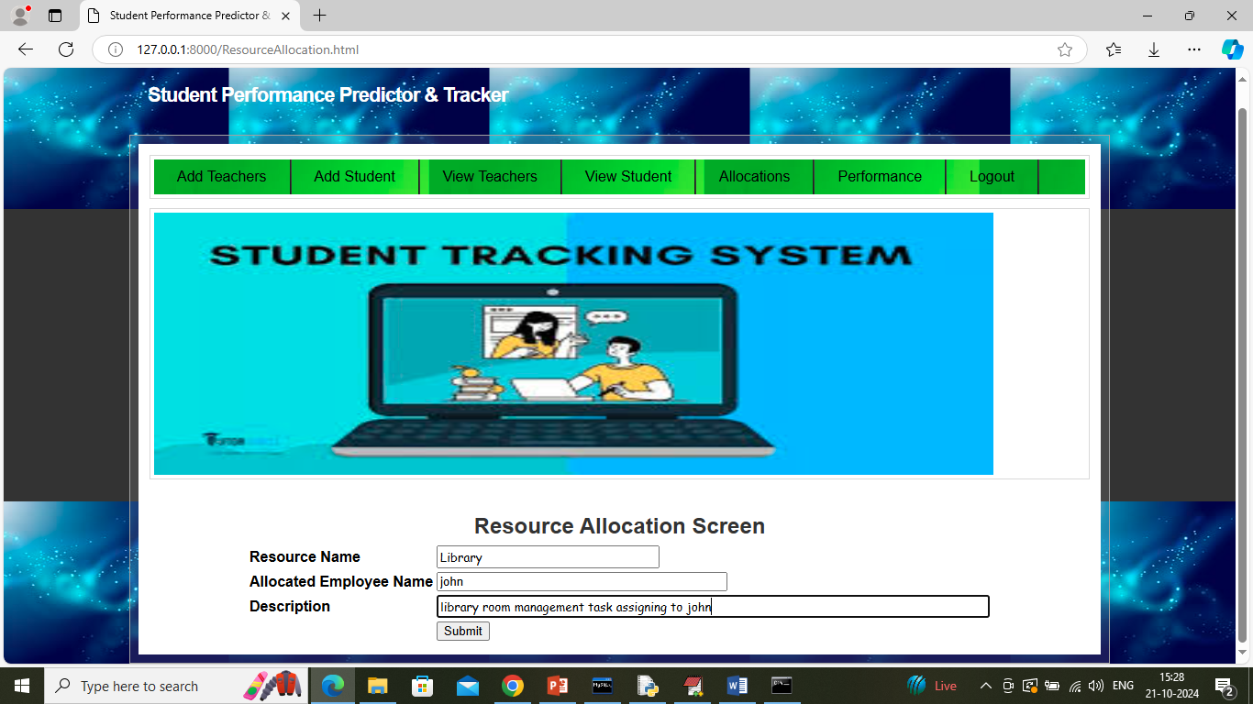

In above screen admin is allocating resource to employee and then press button to get below page

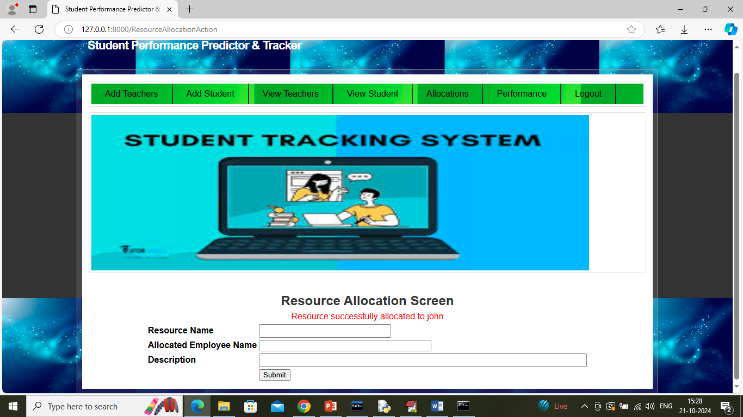

In above screen resource allocated to employee and now click on ‘School Performance’ link to get below page

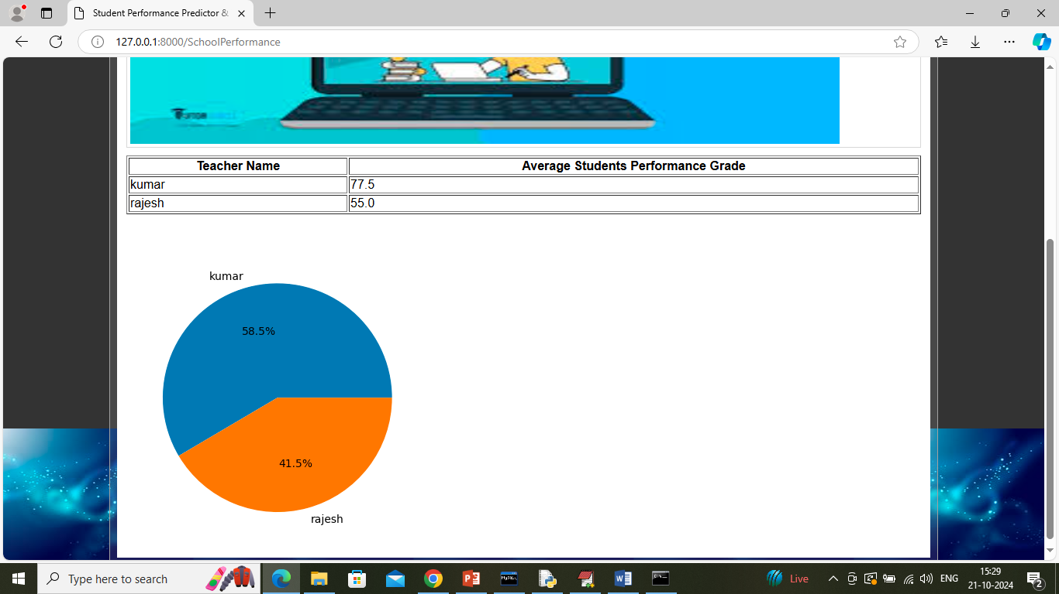

In above screen admin can view overall students average grades obtained under teacher name and in graph can see which faculty score which is obtained by all students under that faculty. Now logout and login as Teacher

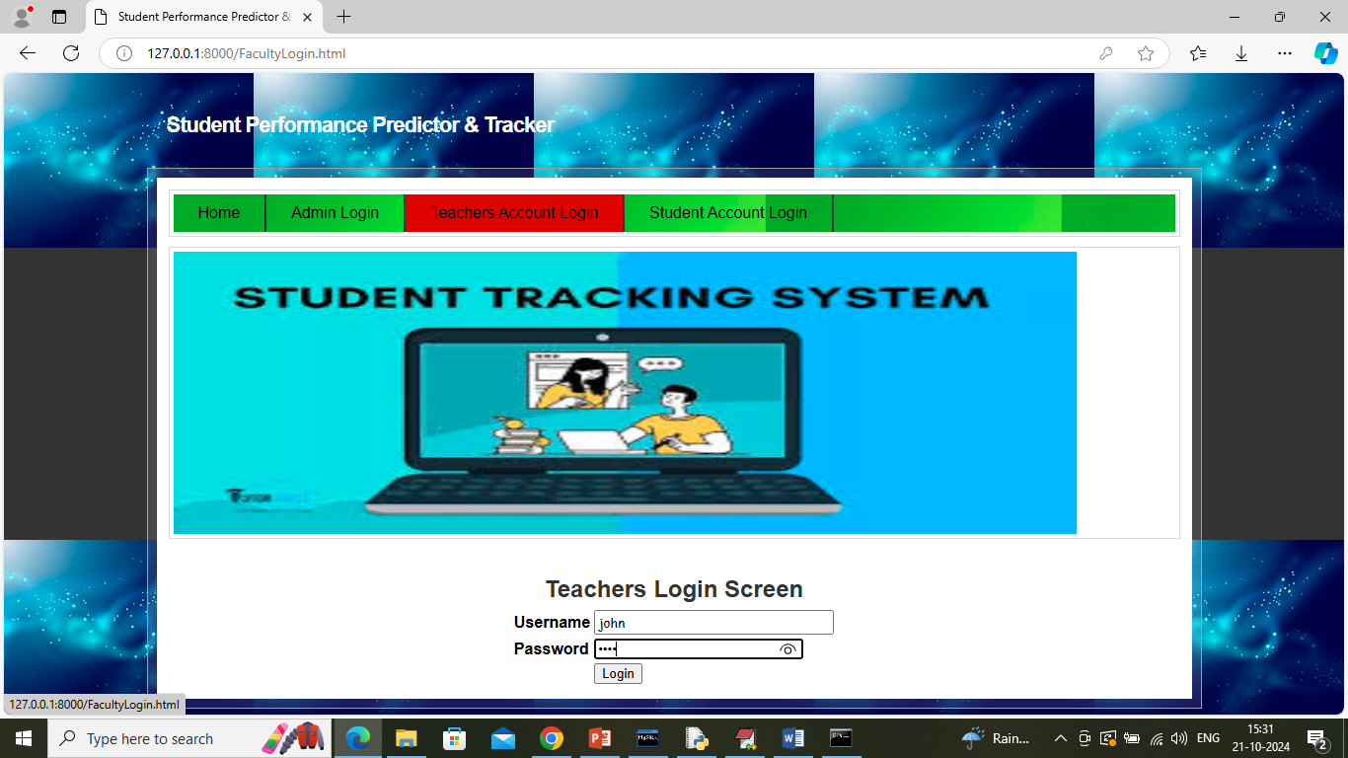

In above screen teacher is login and after login will get below page

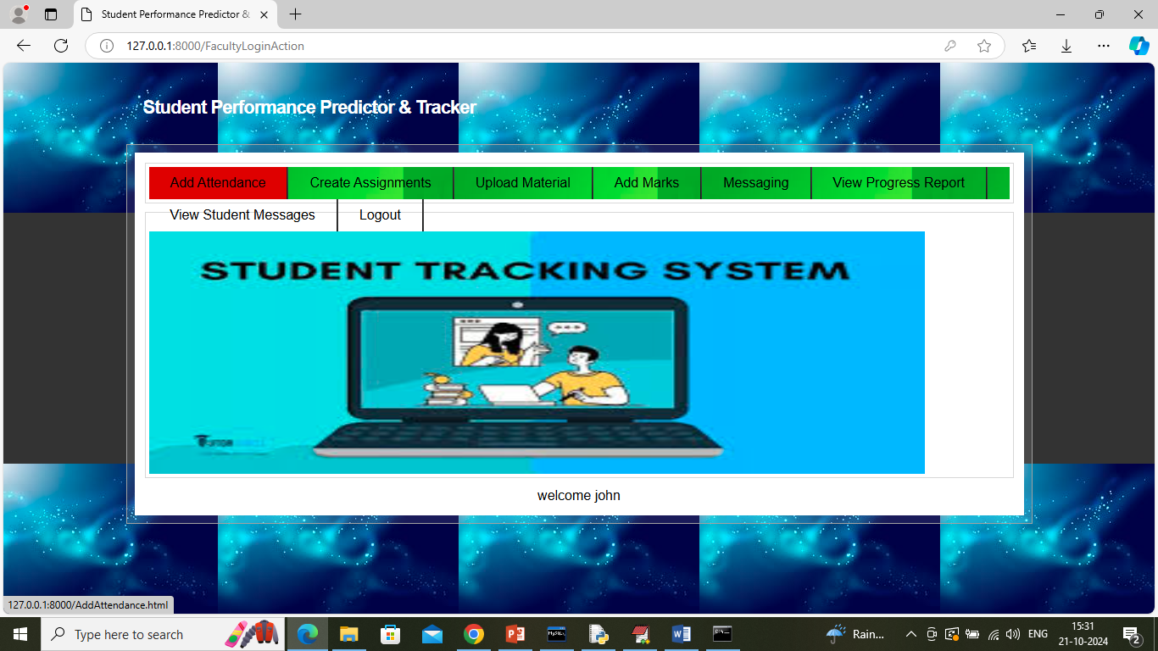

In above screen faculty can click on ‘Add Attendance’ link to get below page

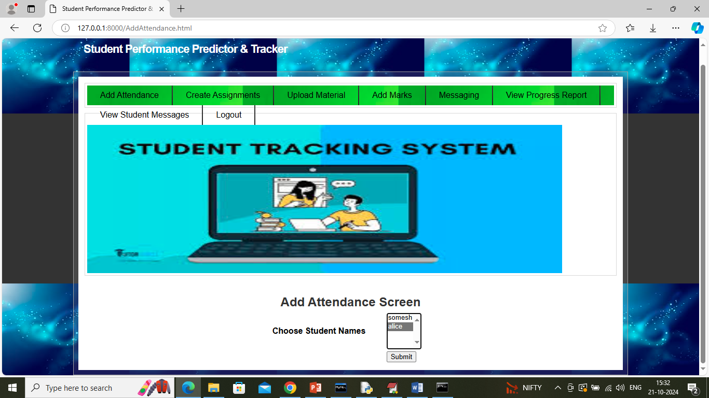

In above screen faculty can select present multiple students names by holding CTRL key from keyboard and then press button to get below page

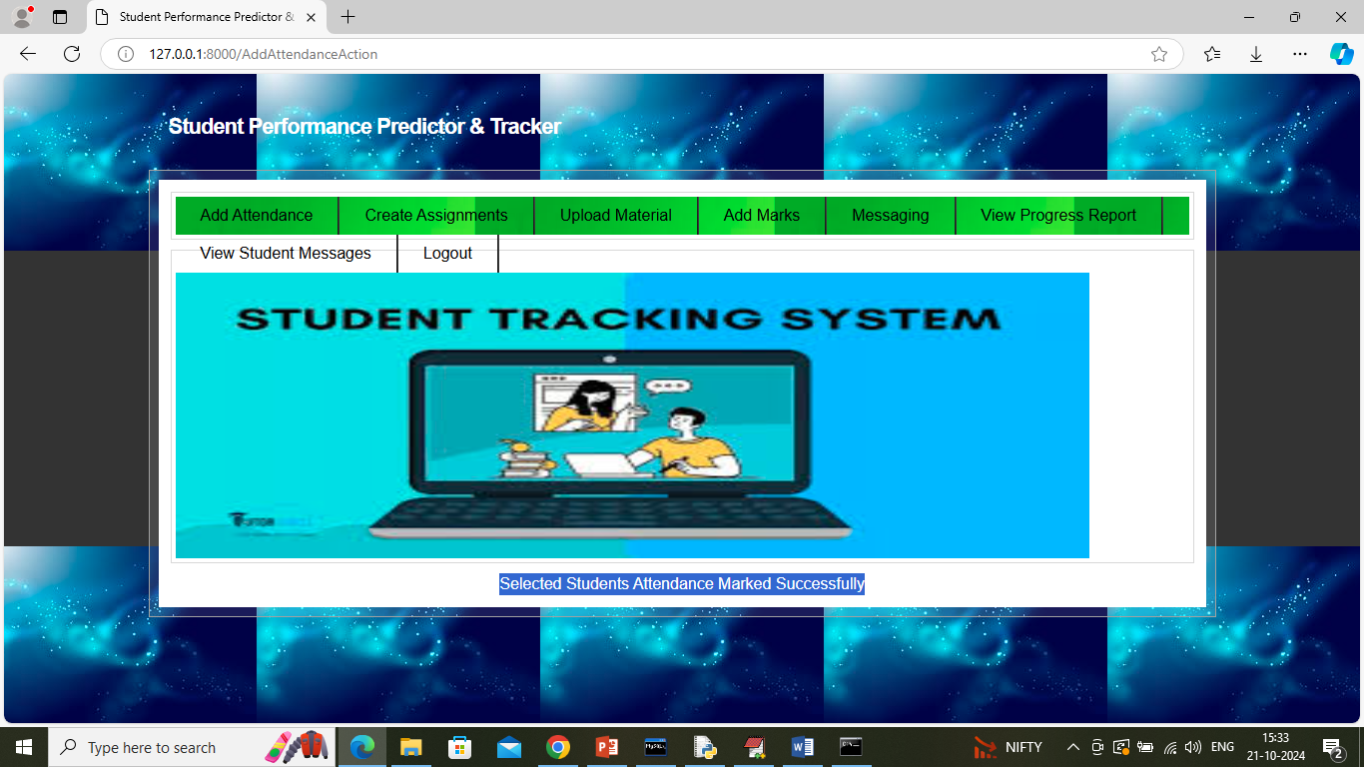

In above screen student attendance marked successfully and then click on ‘Create Assignment’ link to get below page

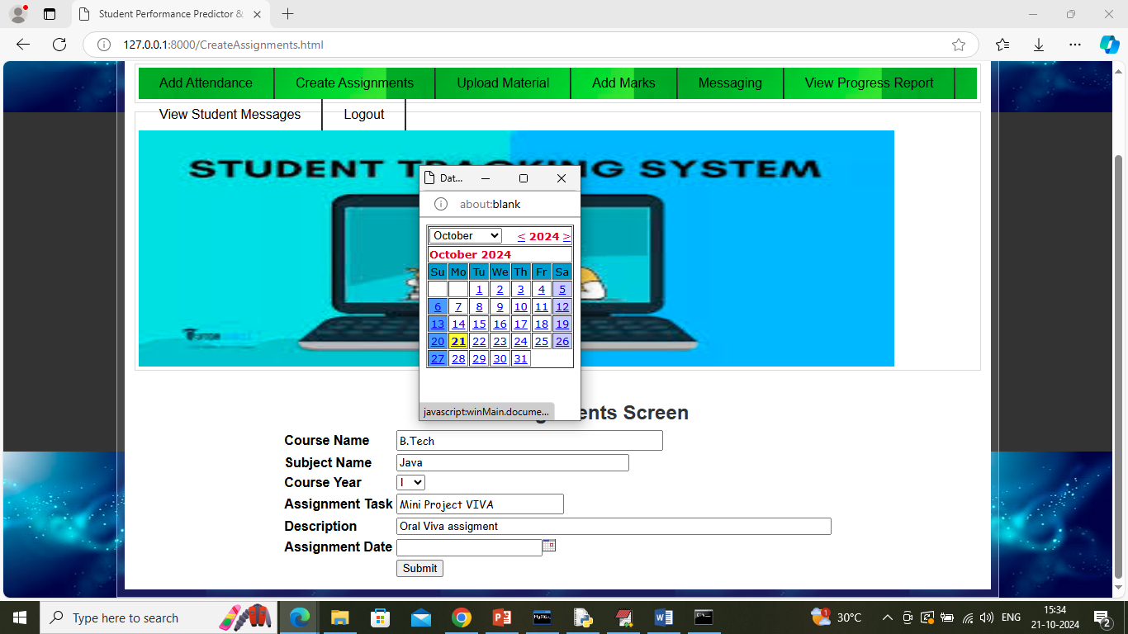

In above screen faculty will create assignment task and then select date and then press button to get below page

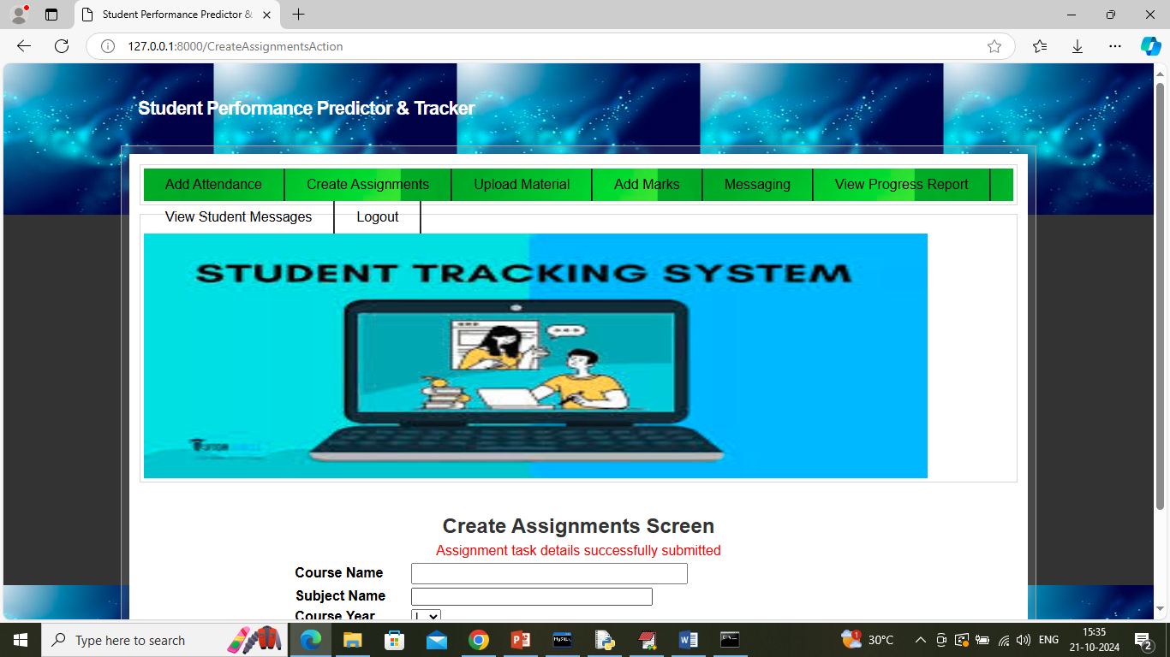

In above screen assignment details added and now click on ‘Upload Material’ link to get below page

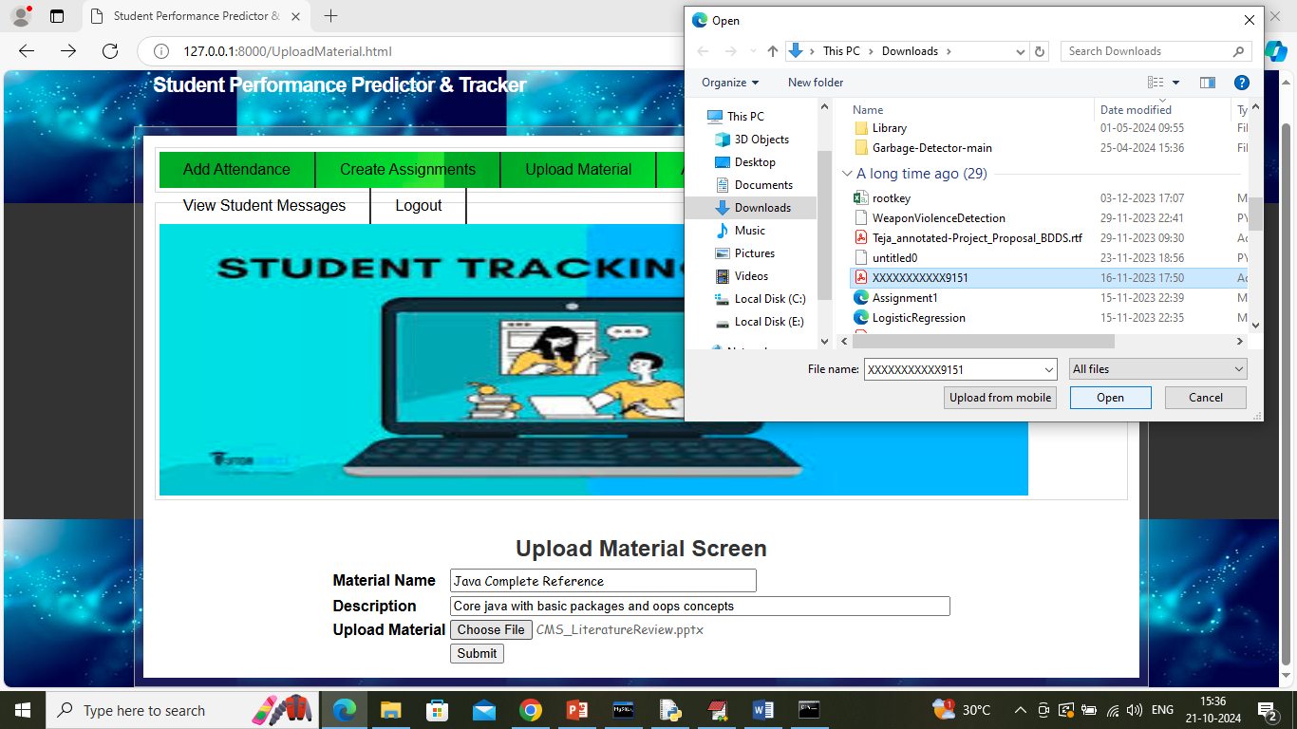

In above screen teacher uploading study material and then press button to get below page

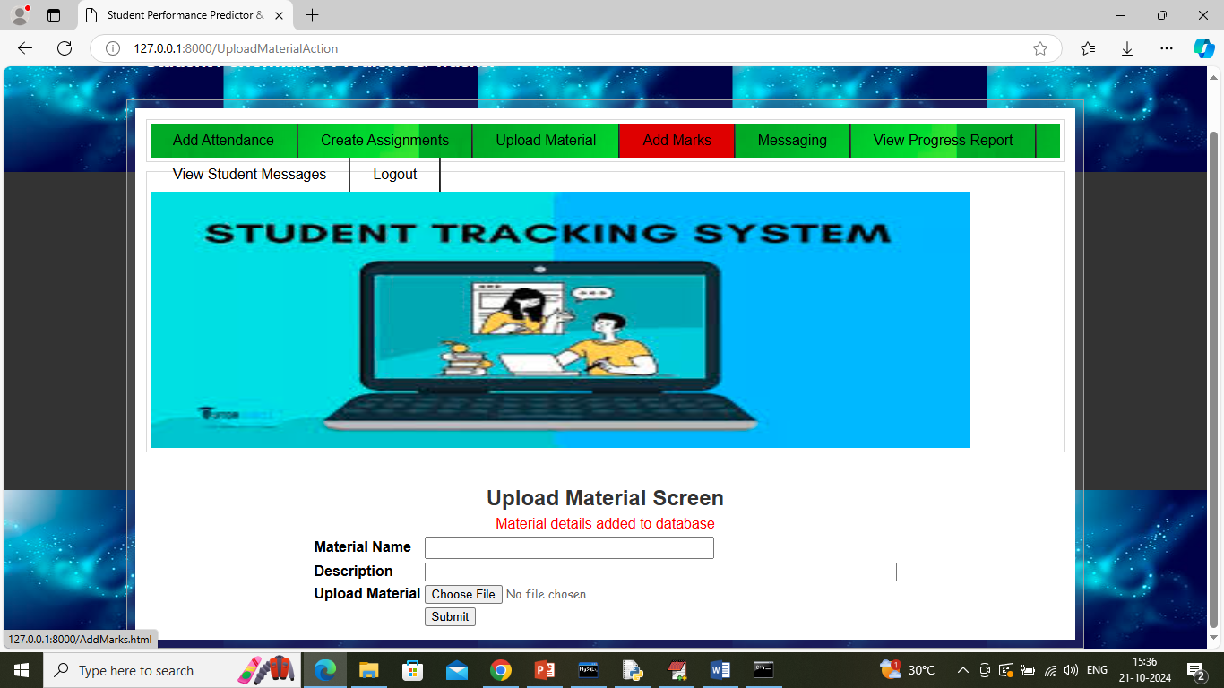

In above screen material details added and now click on ‘Add Marks’ link to get below page

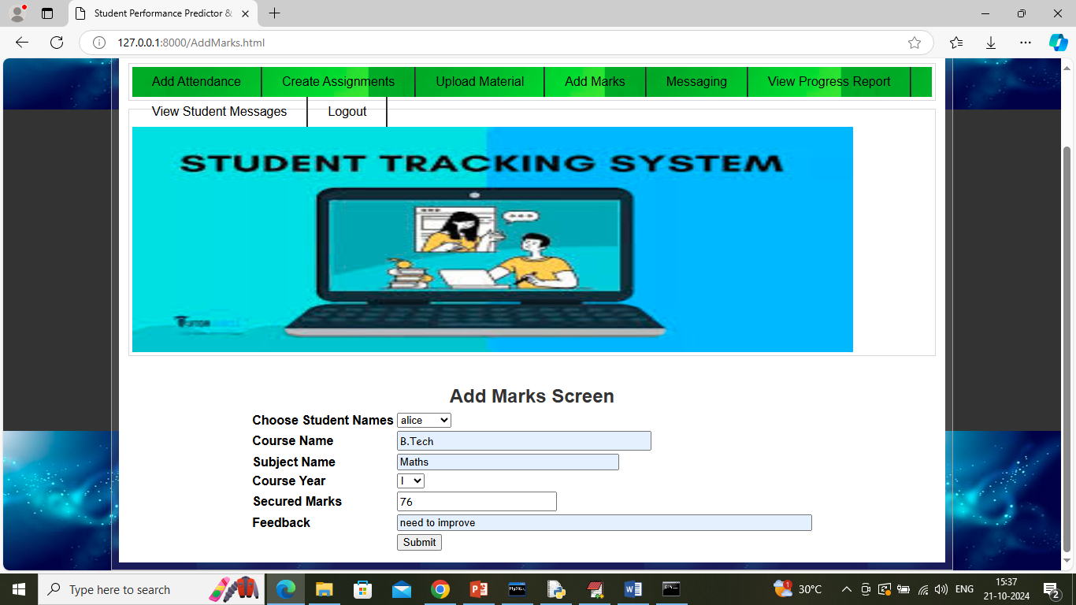

In above screen teacher can add marks for each subject for each student and then press button to get below page

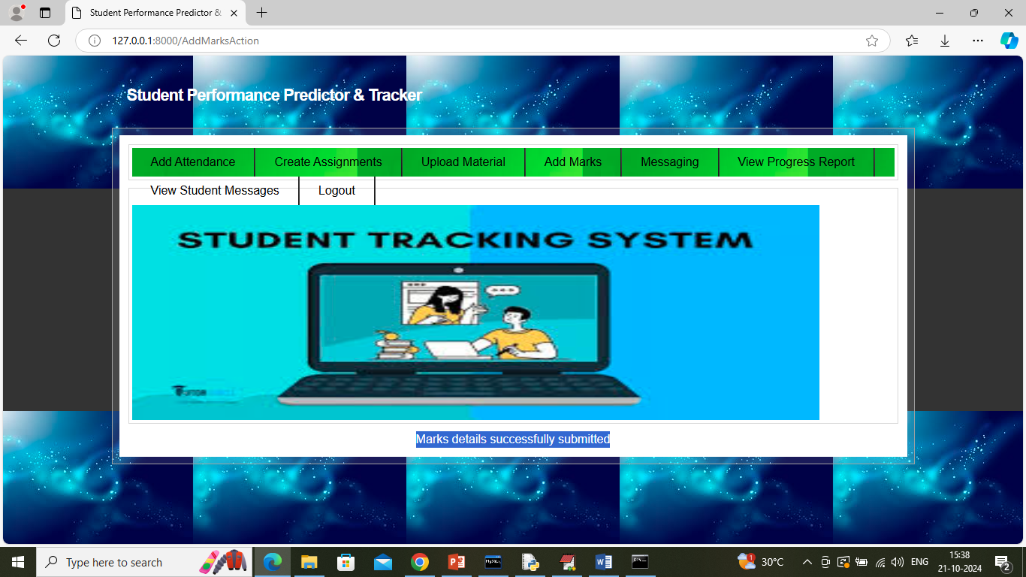

In above screen marks details successfully added and similarly you can add for all subjects and now click on ‘Messaging’ link to get below page

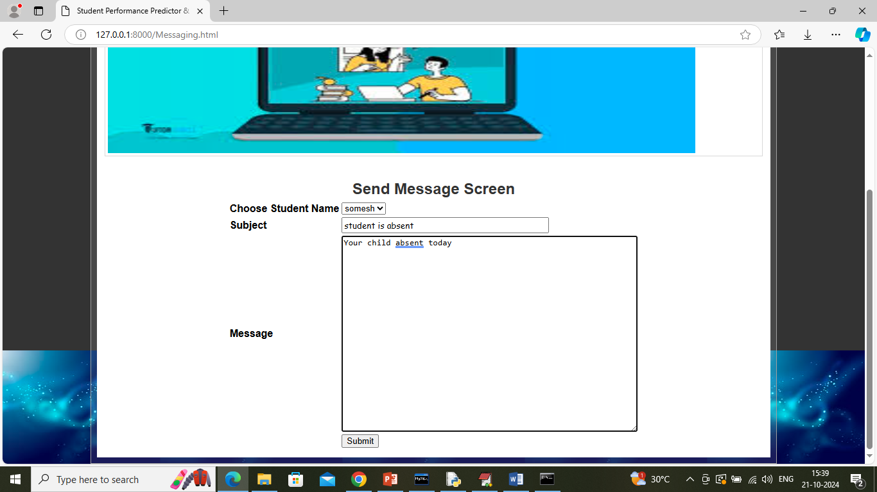

In above screen teacher can post message which will send to student and their parent’s mail

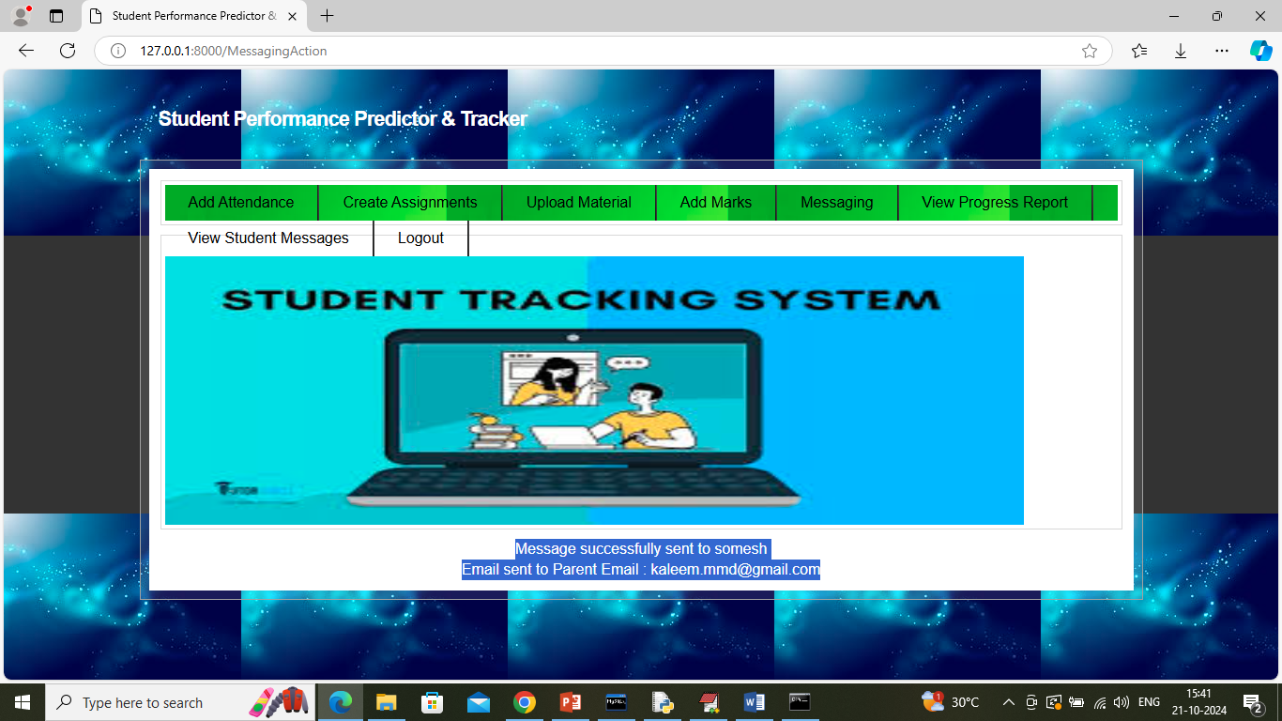

In above screen can see message sent to student parent and now can see same in below Email Page

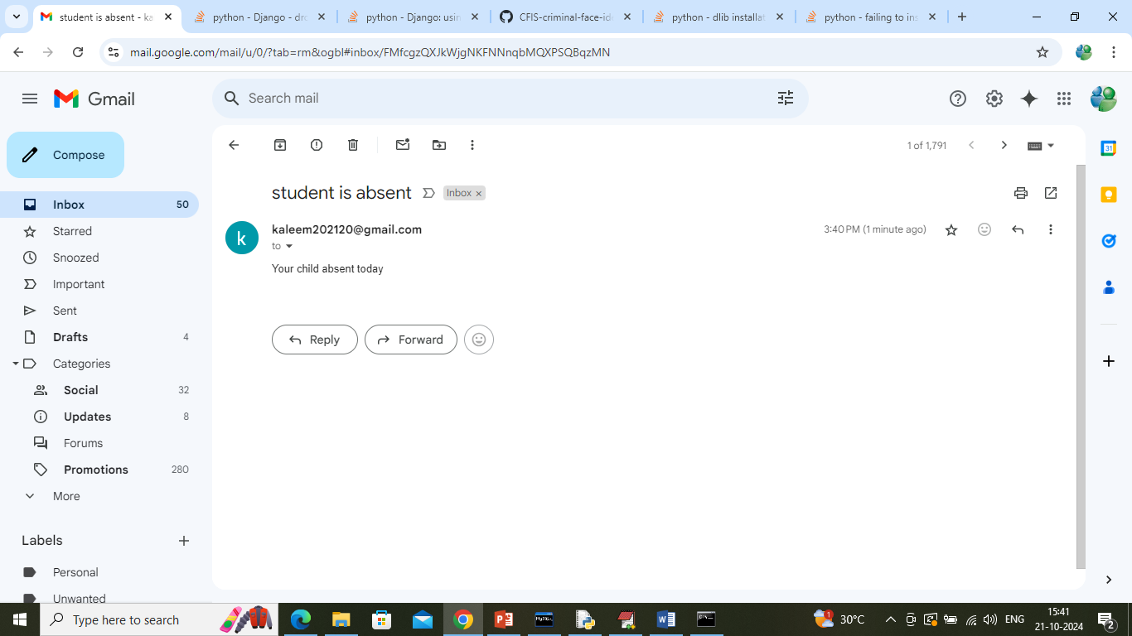

In above screen parent can see the mail and now click on ‘View Progress Marks’ link to get below page

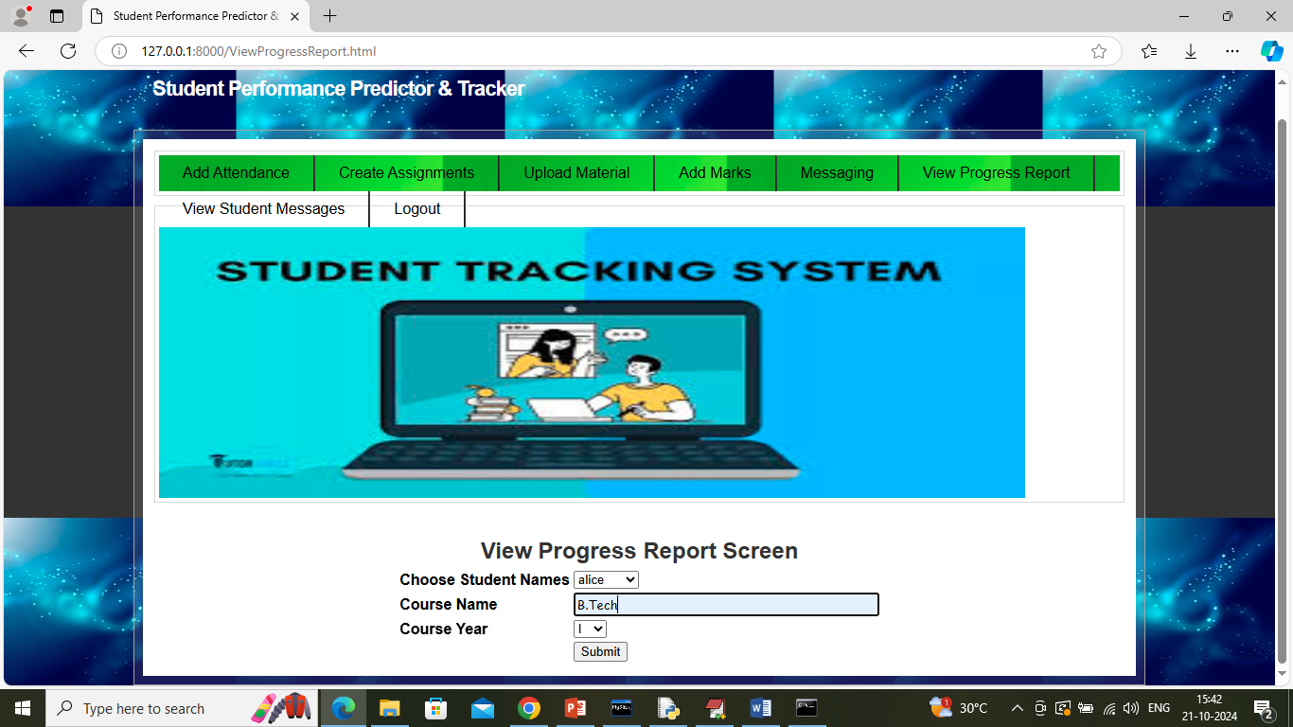

In above screen teacher can select student name along with course details and then press button to get below page

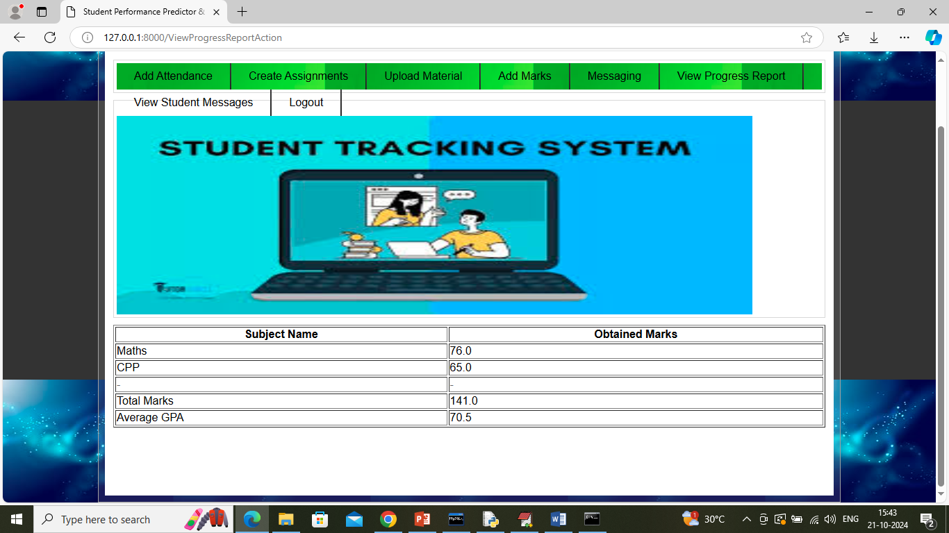

In above screen teacher can view total and average marks secured by students along with subject details and now click on ‘View Student Messages’ link to view messages from students

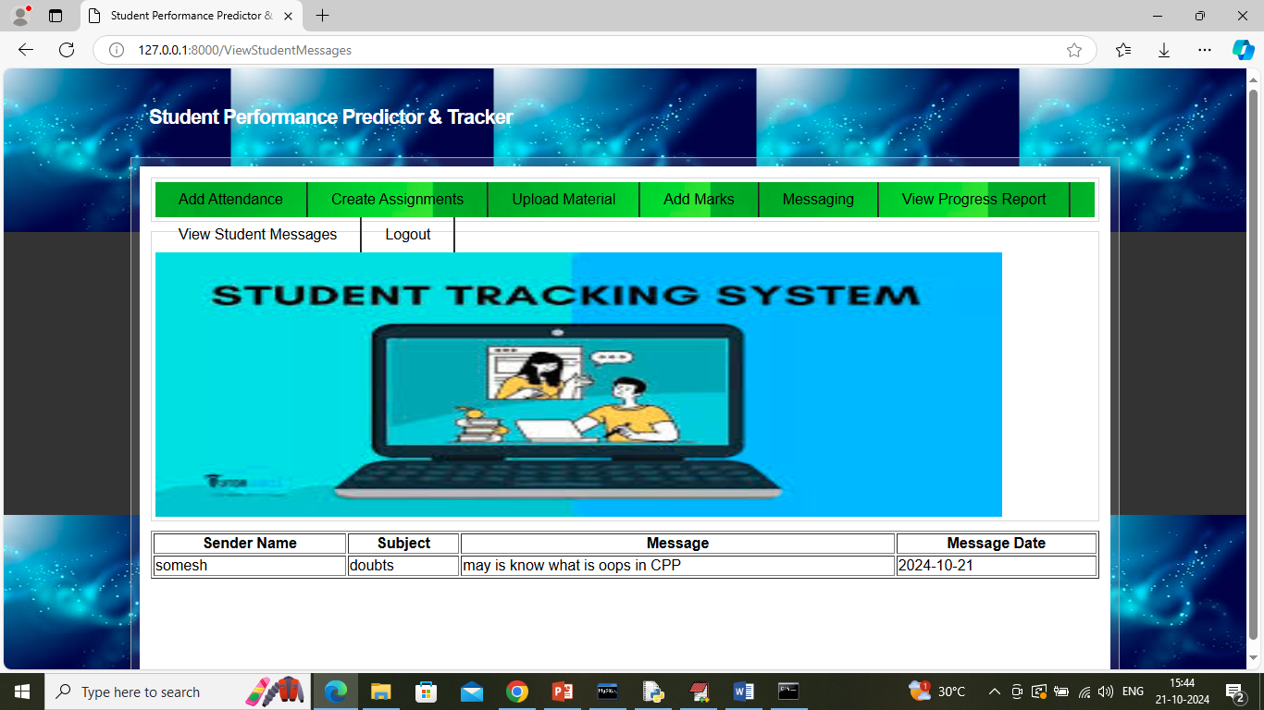

In above screen faculty can view list of messages posted by students and now logout and login as student

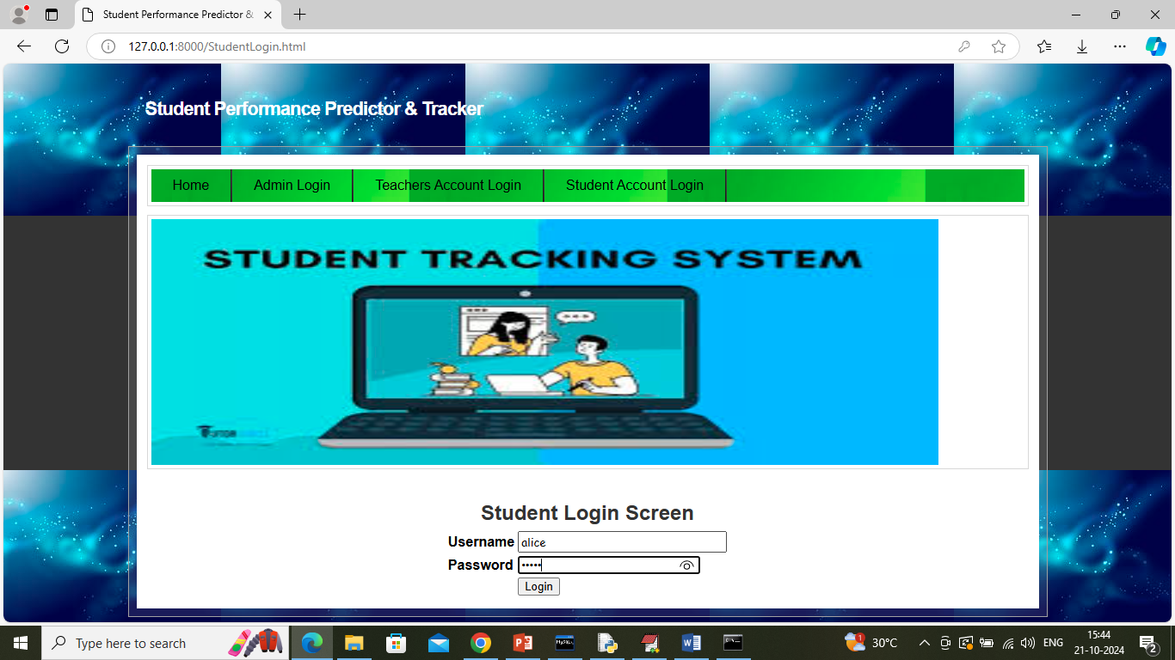

In above screen student is login and after login will get below page

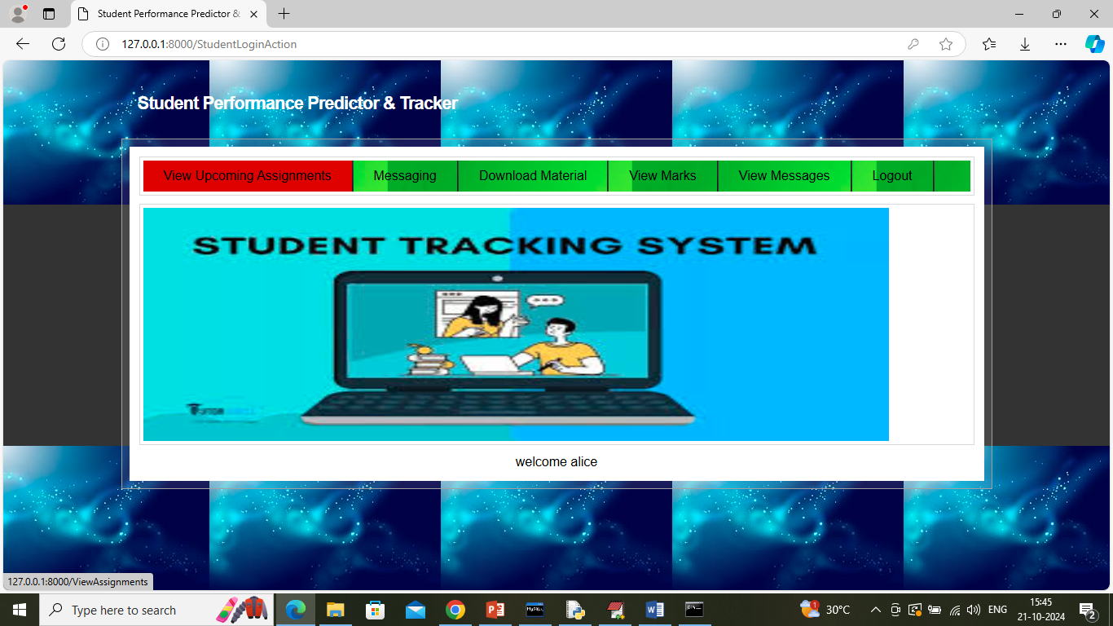

In above screen student can click on ‘View Upcoming Assignments’ link to view all assignment details

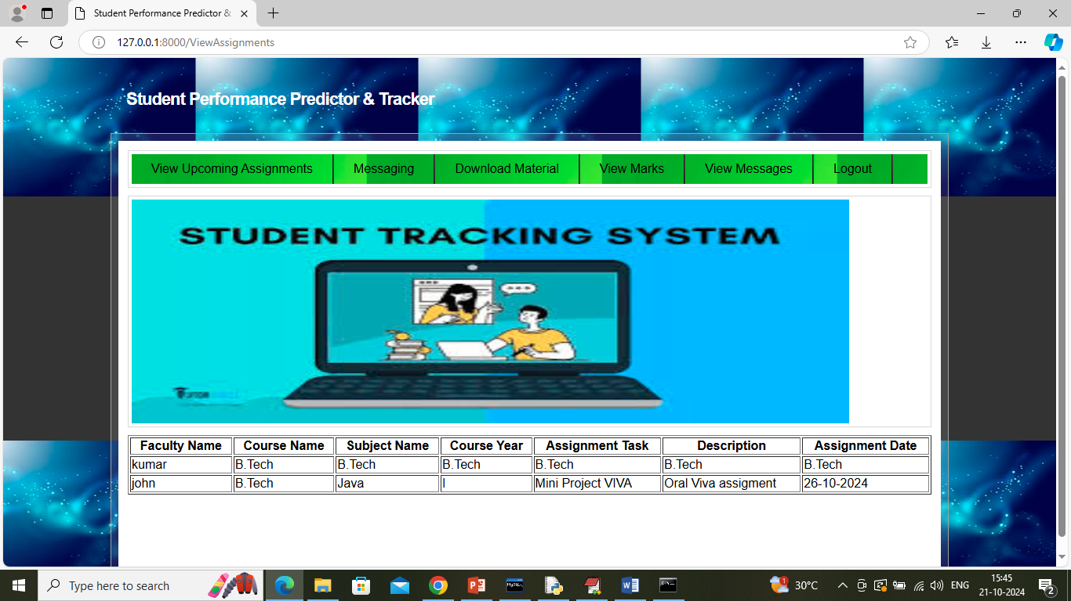

In above screen student can view list of assignment and now click on ‘Messaging’ link to send message to faculty

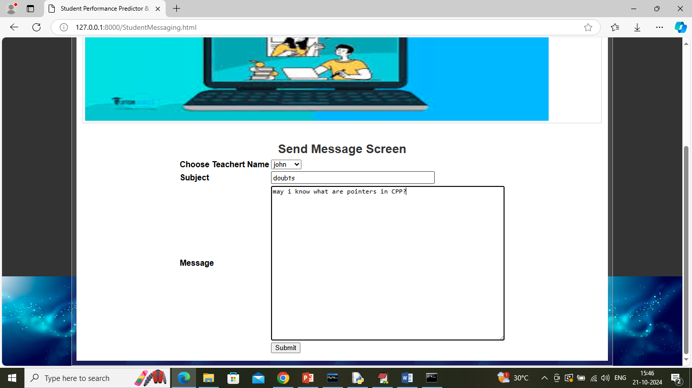

In above screen student can post messages to faculty and now click on ‘Download Material’ link to view list of available material and can download desired material

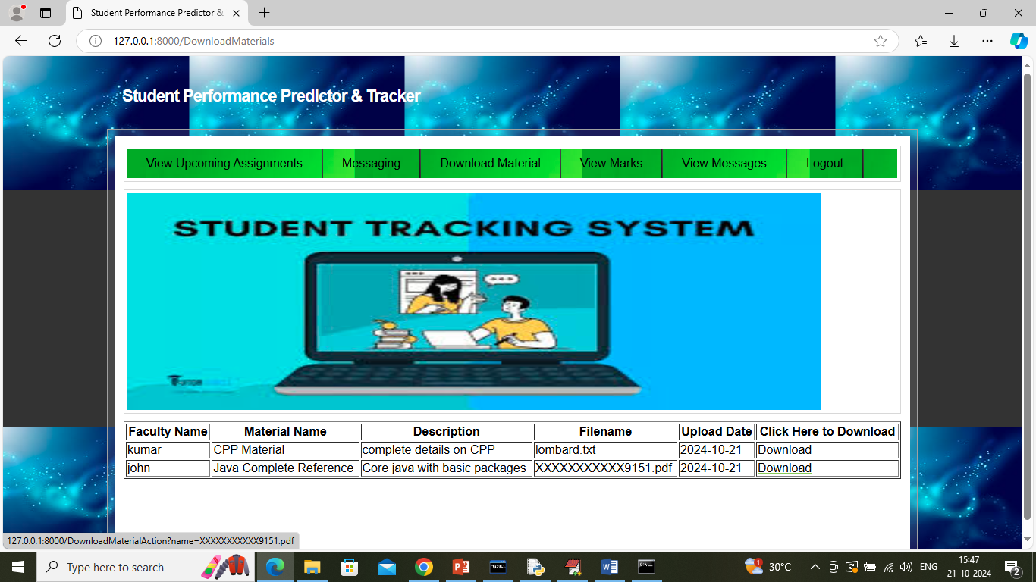

In above screen user can view list of materials and can click on ‘Download’ link to download desired material and get below page

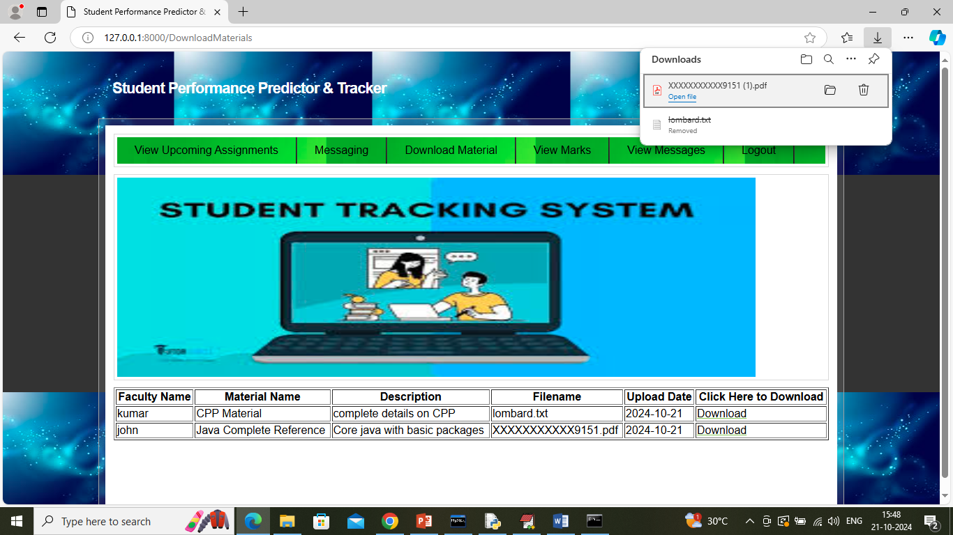

In above screen material downloaded in browser task bar can see downloaded status and now click on ‘View Marks’ link to get below page

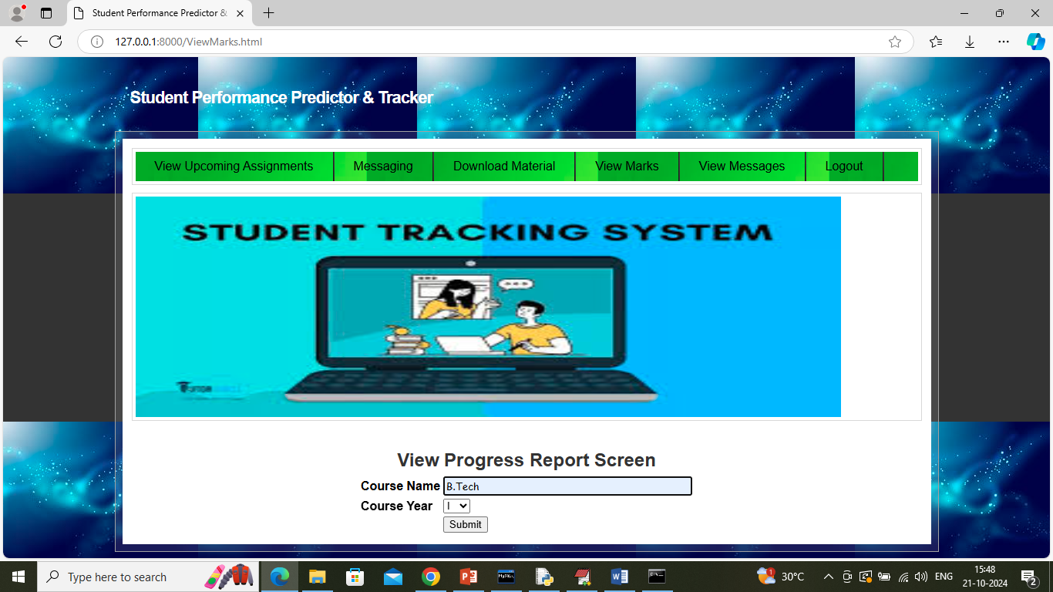

In above screen student can select course name and year and then press button to get below page

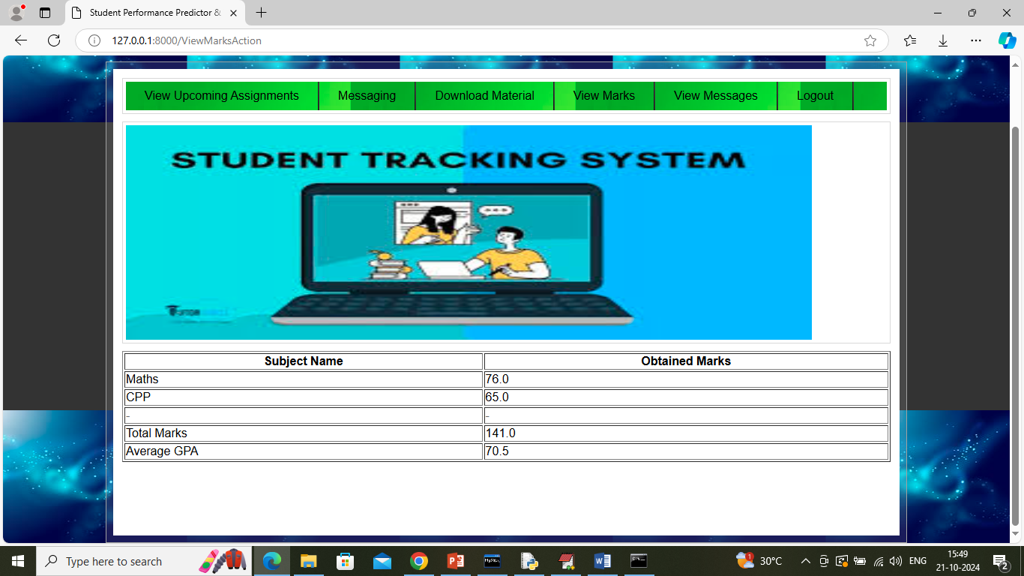

In above screen student can view all obtained marks and now click on ‘View Messages’ link to get below page

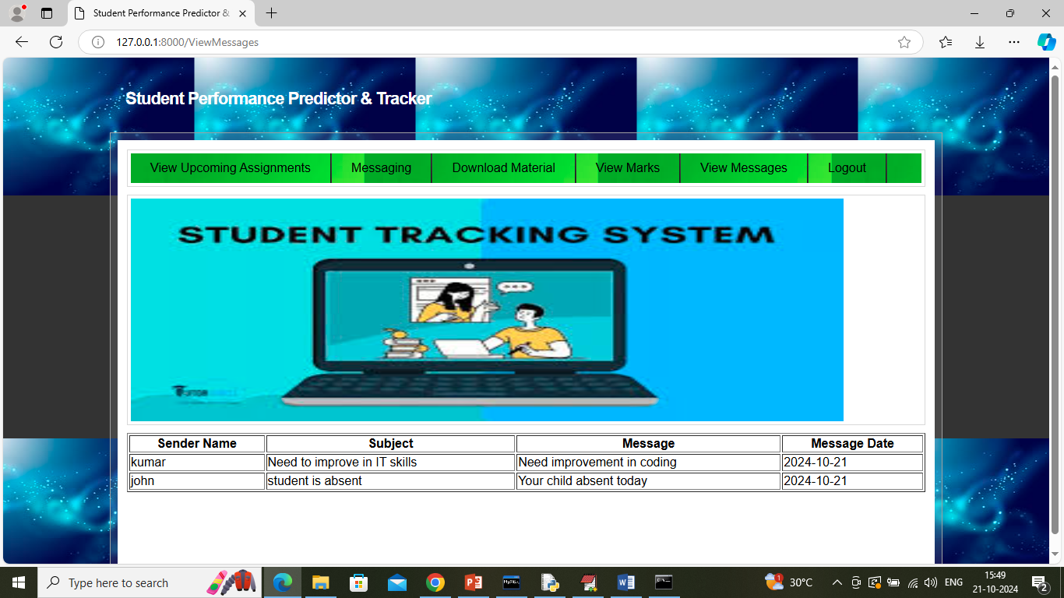

In above screen student can view all messages sent by teachers.

Similarly by following above screens you can manage and track all students performance details